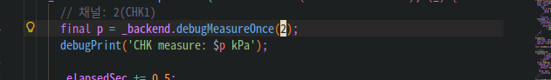
Main.dart

vacuum_backend.dart
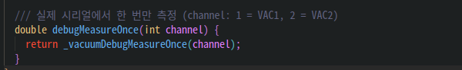
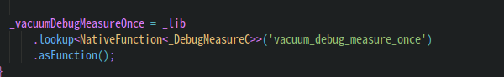
vacuum_backend_api.cpp
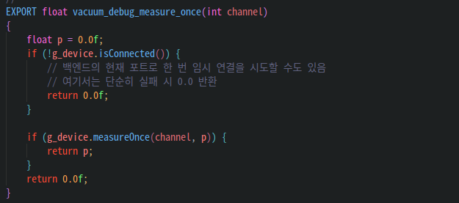

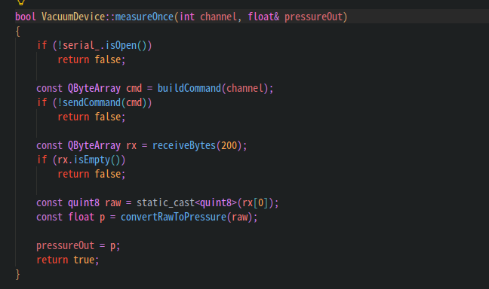
vacuum_device.cpp

